4.7 Change of Variables in Multiple Integrals Worksheet

- Let R be the region bounded by the curves . Let and .
- Solve the equations for x as a function of u and v. Similarly, obtain y as a function of u and v. That is, determine .

- Let and . Draw the region R in the u, v coordinate system.

- What is ?

- Use your answers from parts (a) – (c) to perform a change of variables on the double integral .

- The transformation takes the triangle with vertices to the region R as shown below. Evaluate area of R.
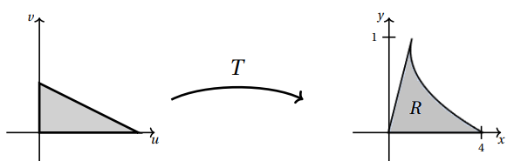

- Let T be the transformation given by . Let S be the triangle in the uv-plane whose vertices are . Let R be the region obtained when T transform S into a region in the xy-plane, that is .
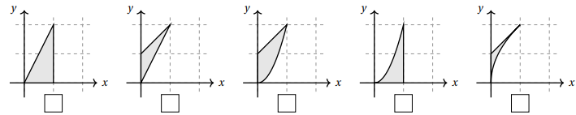
- Check the box below the picture which represents the region R (assume axes are scaled by 1s).

- Express as an integral over S.

- For each transformation T below circle “yes” or “no” depending on whether or not it takes the rectangular region S, in the uv-plane to the parallelogram region R in the xy-plane with vertices .
- YES NO |  | - YES NO
- YES NO |  | - YES NO

- Let R be the rectangle whose vertices are shown at the right.
- Exactly one of the following defines a transformation from the uv-plane to the xy-plane with , where . Circle the correct formula for .

- Determine if is negative, zero, or positive.

- Let E be the trapezoid with vertices . Using the change of variables change into an integral that is easier to evaluate. You do not need to evaluate the resulting integral.

- Use the transformation to evaluate the integral , where R is the region bounded by the ellipse .

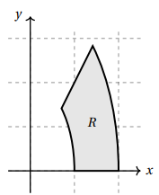
- Suppose R is the region in the first quadrant between the ellipses and and the lines and shown at the right. Using the transformation , find the integrand and limits of integration expressing the integral as an iterated integral over a subset S in the uv-plane with .

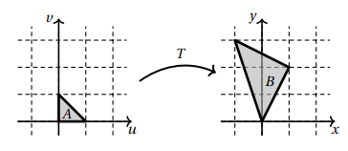
- Find a transformation T that transforms the triangular region with vertices to the triangular region B with vertices . As shown in the picture to the right.

We will try to create a transformation which maps , , and .

- Let T be the transformation . Let be the unit square in the uv-plan and let be the region that is the is the image of S under T.
- Check the box below that corresponds to the region R.

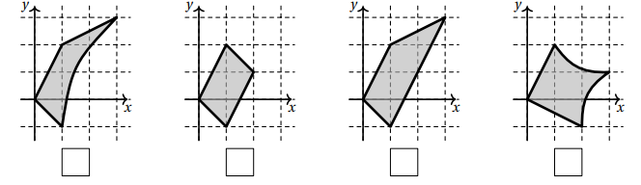

- Fill in the limits and integrand of the integral below so that it computes as an integral over the square S.

- Use an appropriate change of variables to evaluate the integral , where R is the rectangle with vertices .

- Let E be the region bounded by . Find an appropriate change of variables and change into an integral that is easier to evaluate. You do not need to evaluate the resulting integral.

- Let R be a parallelogram with vertices . If , then compute .

